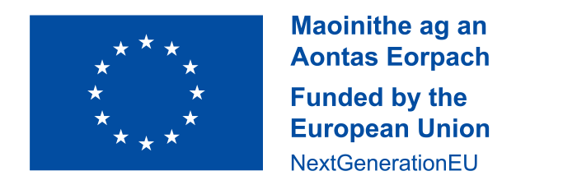

This school received a grant in 2021 to implement initiatives aimed at addressing the digital divide and support our learners at risk of educational disadvantage as a consequence, as part of the Irish National Recovery and Resilience Plan (NRRP) a project under the Recovery and Resilience Facility funded by the European Union through NextGenerationEU. This funding was used to purchase a set of tablets for pupil use and interactive whiteboard, as per criteria outlined in circular 0060/2021).